**Equipment for Boys' and Men's Lacrosse**

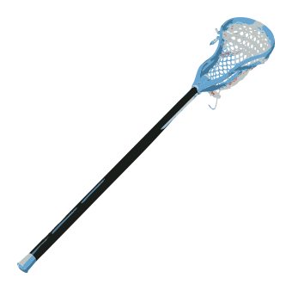

**The Crosse:**

The crosse (lacrosse stick) is made of wood, laminated wood or synthetic material, with a shaped net pocket at the end. The crosse must be an overall length of 40 - 42 inches for attackmen and midfielders, or 52 - 72 inches for defensemen. The head of the crosse must be 6.5 - 10 inches wide, except a goalie's crosse which may be 10 - 12 inches wide. The pocket of a crosse shall be deemed illegal if the top surface of a lacrosse ball, when placed in the head of the crosse, is below the bottom edge of the side wall.



**The Ball:**

The ball must be made of solid rubber and can be white, yellow or orange. The ball is 7.75 - 8 inches in circumference and 5 - 5.25 ounces. All lacrosse balls must meet NOCSAE (National Operating Committee on Standards for Athletic Equipment) standards and include the words "Meets NOCSAE Standard".

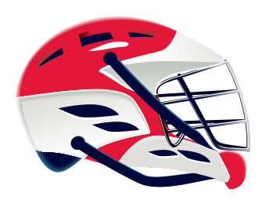

**The Helmet:**

A protective helmet, equipped with face mask, chin pad and a cupped four point chin strap fastened to all four hookups, must be worn by all players. All helmets and face masks must be NOCSAE (National Operating Committee on Standards for Athletic Equipment) approved.

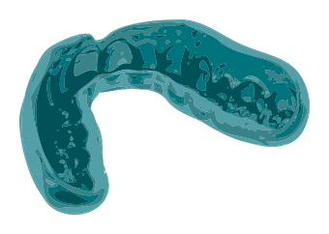

**The Mouthpiece:**

The mouthpiece must be a highly visible color and is mandatory.

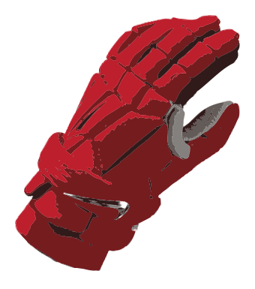

**The Glove:**

All players are required to wear protective gloves. The cutting or altering of gloves is prohibited.

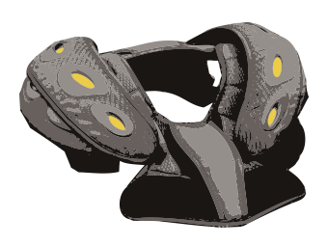

**Other Protective Equipment:**

All players, with the exception of the goalkeeper, must wear shoulder pads. Arm pads are required and rib pads are strongly recommended, and often required, as are athletic supporters and protective cups for all players.

The goalkeeper is required to wear a throat protector and chest protector, in addition to a helmet, mouthpiece, gloves and a protective cup.

**Equipment for Girls' and Women's Lacrosse**

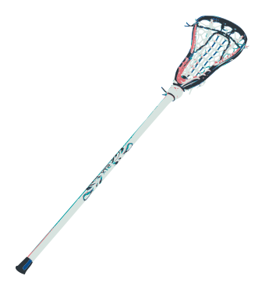

**The Crosse:**

The crosse (lacrosse stick) is made of wood, laminated wood, or synthetic material, with a shaped net pocket at the end. A girl's crosse must be an overall length of 35.5 - 43.25 inches. The head of the crosse must be seven to nine inches wide. The top of the ball when dropped in the pocket must remain above the side walls.* The goalkeeper's crosse may be 35.5- 48 inches long. The head of the crosse may be mesh and up to 12 inches wide.

* Modified Pocket allowed in girls' youth rules at 10U and below.



**The Ball:**

For 10U and above, the game ball must be yellow, lime green, or orange, and made of solid rubber, smooth without dimples. All lacrosse balls must meet NOCSAE (National Operating Committee on Standards for Athletic Equipment) standards and include the words "Meets NOCSAE Standard".

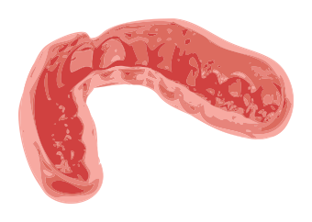

**The Mouthpiece:**

All players must wear mouthguards that fully cover the teeth. The mouthpiece shall be of a readily visible color other than clear or white and must not have graphics of white teeth. The shall be no protruding tabs for field players.

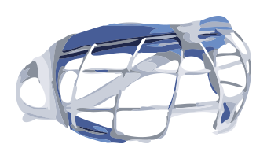

**Eyewear:**

All field players must properly wear protection that meets ASTM standard F3077 for women's adult/youth lacrosse for the appropriate level of play.

**Optional Equipment:**

Close-fitting gloves and headgear that meets ASTM standard F3137 are optional and may be worn by all players.

See approved listings for: [Eyewear](https://www.uslacrosse.org/safety/equipment/approved-eyewear-list) | [Sticks](https://www.uslacrosse.org/safety/equipment/legal-sticks) | [Headgear](https://www.uslacrosse.org/safety/equipment/approved-womens-headgear)

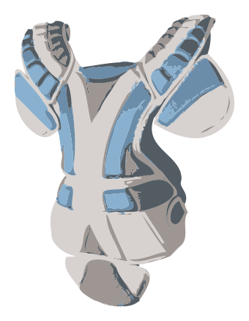

**The Goalkeeper's Equipment:**

The goalkeeper must wear a helmet with face mask (NOCSAE approved), separate throat protector, padded gloves, mouth piece, and chest protector. The goalkeeper may wear padding on arms, legs, and shoulders which does not excessively increase the size of those body parts. High school level and below must wear padding on thighs and shins. Youth level must wear some form of abdominal and pelvic protection.